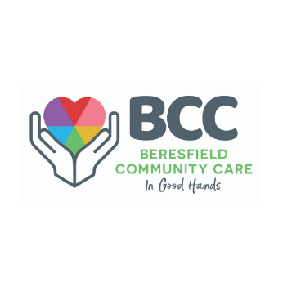 | Read all about it!  What’s News?  Spring 2022

A Message from the Manager
As the cool air becomes warmer and the sun sets a little later, I'm pleased to bring you the Spring edition of “What’s News?” - the Beresfield Community Care newsletter.
What a big few months we've had. Firstly I'd like to thank you all for showing patience and understanding as we continue to navigate our in-home care services through this evolving COVID-19 climate. Like us, providers across the country currently prioritise personal care and medication services due to many community members (including our Support Workers) being in isolation with illness. We're working hard to get back to our full roster soon.
In this jam-packed issue, you'll find updates on our Social Supports, home safety visits by Fire & Rescue NSW and a yummy recipe from our friends at Meals on Wheels.

In some exciting news, we will soon be launching our email newsletters. Make sure you subscribe by scanning the QR code on the back page. You can also visit www.bccare.org.au to subscribe.
Happy reading.
Tania Ewin
Manager
Beresfield Community Care

In this issue
- Anti-Viral Medication
- Covid vs the Flu
- Social Support
- Home Safety Visits
- NDIS Plan Implementation Directory
- New phone options
- and much more!

 | Find us on Facebook  @beresfieldcommunitycare

Covid-19 Anti-Viral Medication can be life saving
If you test positive for COVID-19 (via RAT or PCR), talk to your GP about oral anti-viral medication. They are effective in reducing the risk of serious illness.
You could be eligible for access to anti-viral medication if you:
- Are 70 years or older with or without symptoms
- Are 50 years or older with additional risk factors or;
- Are a First Nations person aged 30 years or over with additional risk factors
Anti-viral treatments are effective when taken early. Treatment needs to begin within five days of a positive COVID-19 diagnosis, and it is best to start within 24 hours.
More information (including additional risk factors): http://www.health.gov.au/health-alerts/covid-19/treatments/oral

 | We are closed on Monday, 3 October for the Labour Day Public Holiday.  In an emergency use your personal alarm (if you have one) or call 000.

COVID-19 vs the Flu
COVID-19 and the flu may seem similar in that they can both result in serious illness or death, but they are caused by different viruses, which means they need different vaccines and treatments.

Covid-19
- Contagious respiratory illness caused by the SARS-CoV-2 virus
- Symptoms usually appear in the first 7 days after exposure but can develop between day 7 and 14
- Usually infectious from 1 to 2 days before symptoms start until 5 to 7 days later
- Spreads more easily than the flu, and people remain contagious for longer periods of time
- Vaccine: COVID-19 vaccines

Flu
- Contagious respiratory illness caused by the influenza A and B viruses
- Symptoms usually appear between 2 to 4 days after exposure.
- Usually infections from the day before symptoms start until 5 to 7 days later
- Generally more serious for children than COVID
- Vaccine: Flu shot

Social Support – individual and Groups
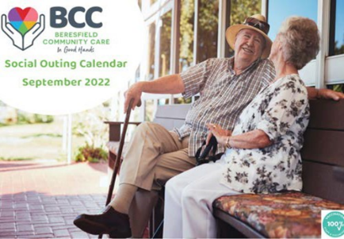 | Get out and about and make  some new friends.  Transport is provided!
We have some exciting group activities coming up, including:
- Variety Fun Day
- Scenic drives with counter lunches
- Men’s Day Out
- Movies
BCC has the following COVID-19 Safe practices:
- Staff and volunteers are 100% vaccinated
- Clients are to be 100% vaccinated
- Currently, we can only have six clients and two staff/volunteers
- Before entering the bus, screening questions are asked, and temperature is taken.
All venues have been risk-assessed as safe and wheelchair friendly.
To book, call us on 4964 1131.

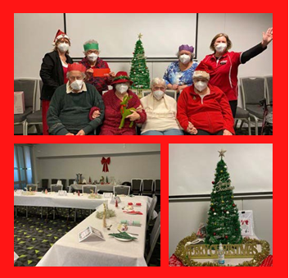
Christmas in July
Some of our clients recently celebrated Christmas in July at Club Maitland City.
Our clients really enjoyed the Christmas- themed bingo and trivia and shared loads of laughter playing the knock’em down Christmas characters game.

We are here to help you stay socially connected!
If you need help socially engaging with your community and family or attending BCC events, please contact your case manager or coordinator of support on 4964 1131. They will be able to discuss available options as part of your funding.

Friendly Reminder
 | We value our client's and employees' safety.  Clients (and other household members) must wear a mask while our support workers are with you (in the same room).  For more information on our current mask policy, please call BCC on 4964 1131.

Disability News

Social Outing Calendar
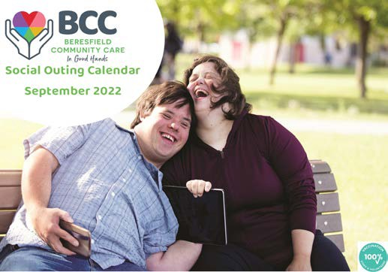 | Our latest Social Outing Calendar includes some exciting activities, including Variety Fun Day, counter lunches, Thursday craft and Body Boosting Bingo.  To book your preferred outing, please call us on 4964 1131.

NDIS Plan Implementation Directory
 | Did you know that NDIS have updated their Plan Implementation Directory which is an accessible platform with helpful resources to make using your NDIS plan easier?  Since launching the directory in May, NDIS has received over 16,000 website visitors, made improvements and added more content to support you. For more information, go to: https://www.ndis.gov.au/participants/plan-implementation-directory

Please let us know:
 | - If there are any changes to your NDIS plan.  - If your plan has moved from NDIA Managed to Plan Managed.  - If you have a new plan.  - If the things you are funded for have changed.  Call us on 4964 1131 so we can make sure you are getting the right service and support

If you need help with the NDIS, or anything else in this newsletter, call us on 4964 1131 and we can help you.

Volunteering Opportunities

BCC is currently looking for Car Drivers and Social Support Volunteers
For more information, contact us on 4964 1131 or check out the Hunter Volunteer Centre website:
- Car Driver: www.hvc.org.au/car-driver
- Social Support Volunteer: www.hvc.org.au/social-support-volunteer

We have made some changes to our phone system
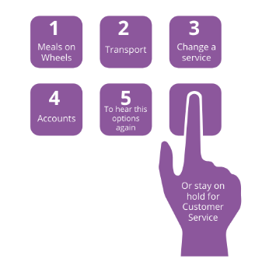 | When you phone 4964 1131, press these numbers to direct call:  - Meals on Wheels  - Transport  - Change a service  - Accounts  - To hear these options again  Or stay on hold for Customer Service.

Advisory Council
 | We're still calling for Expressions of Interest from interested community members.  The Council aims to engage with clients, carers, and stakeholders in a group setting to identify areas of improvement for BCC's service delivery, policies, and procedures.  For more information or to submit an Expression of Interest, contact Alexandra Andrews on 1300 578 478 or visit http://www.bccare.org.au/blog.

BCC is for everyone in the family!
 | As a large provider in our region, we're an organisation loaded with career opportunities, from traineeships to executive roles. And we're always welcoming volunteers to help give our clients the best experience possible  Call 4964 1131 or visit http://www.bccare.org.au

BCC’s Smoke Free Policy
 | Clients are requested not to use anything that resembles a tobacco product while our workers are present in your home.

Cute Puppy Alert
 | Now that we have your attention, please remember that it is a requirement to have pets secured while services are being conducted.

Do you know that Fire and Rescue NSW offer free home safety visits?

With the easing of COVID-19 restrictions by the NSW government, Fire and Rescue NSW has recommenced its Safety Visits Program. The program targets the community's most vulnerable members and offers free Safety Visits to residents across the state.
You can contact your local fire station for fire safety advice and to register for a Safety Visit.
Safety Visits will be conducted in line with ongoing health requirements to ensure the safety of firefighters and the community. During a visit, they will offer tailored fire safety info to you and your family. They will check that your smoke alarms work and install new ones for free if required.
For more information and to book a visit at: https://www.fire.nsw.gov.au/visits

Daylight Savings Time
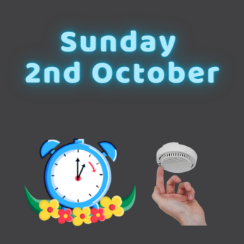 | Daylight saving time starts on Sunday,  2 October. When you change your clocks (spring forward 1 hour), test your smoke alarm and change your alarm batteries.

Bread and Butter Pudding
Food historians trace the history of bread pudding to the early 11th and 12th centuries, as frugal cooks looked for ways to use stale, leftover bread instead of letting it go to waste. There is a good reason it is still around today… An oldie but a goodie.
Dessert, Vegetarian
Difficulty: Easy
Servings: 6
Preparation time: 30 minutes
Cooking time: 30-35 minutes


Ingredients
- 3 eggs
- 150ml pouring cream
- 450ml milk
- 2 1/2 tbsp caster sugar
- Grated zest of 1/2 orange
- 1/2 tsp vanilla essence
- 1/2 tsp cinnamon
- 7 slices (approximately 300g) of day-old bread (or let them dry out for an hour) with crusts cut off
- 45g unsalted butter
- 45g sultanas
- 480mls custard or cream to serve

Method
- Preheat the fan-forced oven to 160°C
(170°C for a conventional oven).
- Lightly grease a large baking tray.
- Combine eggs, cream, milk, caster sugar, orange zest, vanilla essence and cinnamon in a large bowl. Whisk vigorously to combine and set aside.
- Butter the slices of bread on both sides, remove crusts and cut into large triangles—place in the base of the baking tray (ensure the base is fully covered).
- Scatter some of the sultanas over the bread slices, then repeat in layers until all the bread has been used.
- Then pour the milk mixture evenly over the bread.
- Bake for 30 to 35 minutes, until cooked through and gently browned on top.
- Remove from the oven and let stand for 10 minutes.
- Serve with custard or cream.

Subscribe to our new email newsletter
 | Scan the QR code or go to our website  http://www.bccare.org.au




ADSSI Limited T/A Beresfield Community Care
10/16 Huntingdale Drive, Thornton NSW 2320
E enquiries @bccare.org.au W bccare.org.au P 02 4964 1131
We are situated on Darkinjung, Wonnarua, Awabakal and Gringai lands and acknowledge the Traditional Custodians of these lands. We pay our respects to the Elders, past, present and future, and recognise their continuing connection and contribution to this land.
We affirm the right to equality, respect and fairness for LGBTIQ clients, staff and volunteers.


