Read all about it!

BCC

News

W I N T E R | 2 0 2 2

Message from the Manager
I am pleased to bring you the second edition of Beresfield Community Care's newsletter for 2022. The seasons are changing, and the air has a fresh chill.

Big things are happening at BCC. We celebrated National Volunteer Week, a time to recognise our wonderful volunteers for their dedication to helping deliver our services. If you enjoy cooking, check out the soup recipe at the back of this newsletter.

Unfortunately, some services are still being impacted by the high amount of COVID community transmission (including our support staff), staff being in isolation due to COVID, or being unwell with the seasonal flu. Client and staff safety is essential, and we want to reduce the risk of illness for everyone. Our rostering team works hard to prioritise personal care and medication services while temporarily scheduling other services around these priorities.

For a little while, this, unfortunately, means service changes and some cancellations. While we understand that this can be frustrating for you and the broader client base, we thank you and our client community for continued patience and understanding as we work to keep everyone safe while following Health guidelines.

Happy reading.
Tania Ewin

Manager
Beresfield Community Care


IN THIS ISSUE
FLU
VACCINATIONS

CUSTOMER SERVICE CHARTER

WINTER SAFETY

ADVISORY COUNCIL

NDIS ETHICAL
PROVIDER UPDATE

NDIS PLAN
IMPLEMENTATION DIRECTORY

WINTER WORD SEARCH

AND MUCH MORE!


@beresfieldcommunitycare

NSW Health recommends that residents book in for their flu vaccine, as infections have increased significantly in recent weeks. Being unvaccinated increases the risks to you, your family, our clients and other staff.
Flu Vaccinations

The NSW Government has just announced that between 1-30 June, we can get the free flu shot to protect ourselves during the winter months. Vaccination helps protect you against severe symptoms. Please see your GP or Pharmacy to get your free vaccine

What is flu (influenza)?
Influenza (the flu) is a highly contagious disease.
Flu can affect anyone but is especially serious for babies and older people.
Flu is not the same as a common cold. The flu is a serious disease that can lead to severe illness or death.

Flu symptoms include runny nose or sneezing, cough or sore throat, fever and chills, headache, body aches, vomiting and diarrhoea (more common in children).

Symptoms usually start about 1 to 3 days after catching the flu and can last for a week or more. If you have the flu, you can be infectious to others from 24 hours before symptoms start until one week after symptoms start.

The flu spreads:
when an infected person coughs or sneezes, and you breathe it in
through direct contact with fluid from an infected person's coughs or sneezes
by touching a contaminated surface with the flu virus on it and then touching your mouth, eyes or nose
Ways of protecting ourselves and others: Get vaccinated.
Stay at home if you are sick and avoid close contact with other people to protect yourself and the community from Flu and COVID-19. Sneeze into your elbow instead of your hands.
Wash your hands thoroughly and often. Transport to vaccination appointments Please contact your care manager to check if you have the funding to book transport to take you to/from your vaccination appointment.

Customer Service Charter
Our Customer Service Charter outlines our commitment to you and what you can expect in your interactions with us.
In providing our services, we will be:

Responsive Professional Accountable Transparent Consultative Innovative
We are committed to ensuring all complaints are taken seriously and handled efficiently, fairly, and confidentially. Please give us feedback about the care and services you receive from us, including when you are not satisfied. If the service received does not meet your expectations, tell us as soon as possible by calling
4964 1131 or email us at enquiries@bccare.org.au
Read more about our Charter at
www.bccare.org.au/


Winter Safety
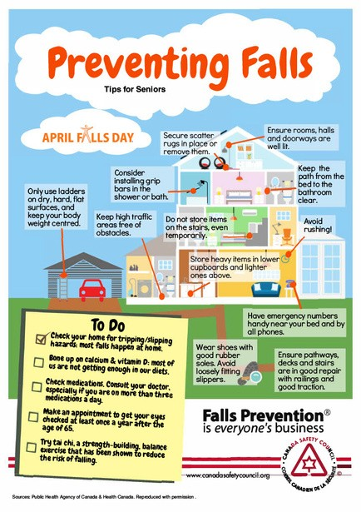
Stay out of harm this winter by checking your:

Smoke alarms Escape plans
Fireplaces and chimneys Heaters
Electric blankets Wheat bags
Fire and Rescue NSW has created a Winter Fire Safety Checklist so you can prepare for winter www.fire.nsw.gov.au/
Heaters
Ensure everything is kept a metre from the heater.

Check your electric and gas heaters before you use them. If you suspect a fault have the item checked by a qualified repairer or replaced. Check all cords for fraying and damage—plug heaters directly into wall sockets.

We have a great range of personal safety and security alarms available for clients.

Quick and easy to install Peace of mind
Cost-effective solutions

Call us today on 4964 1131 to see how we can help.
Do not overload powerboards.
Ensure everything is kept a metre from the heater.
Install any new heaters and use them as per the manufacturer's instructions.
Check your portable outdoor heaters before use and have them serviced or replaced if required. Ensure that the area where you plan to use them is level, well ventilated and away from awnings and other combustible materials.
NEVER use any outdoor heating or cooking equipment inside your home, including those that use 'heat beads' or LPG as a fuel source. This type of equipment is unsuitable for indoor use and can lead to a build-up of lethal gases that could be deadly. Check the manufacturer's recommendations before use.


GOT DINNER SORTED?
delivered to your door!
Snap frozen meals ready to go Excellent quality – natural ingredients! Great range of cuisines
Nutritionally balanced – packed with goodness
Generous serves or mini-meals
Dietary requirements met e.g. Gluten Fee, Vegetarian, cut up
Immediate start – no up-front referral Great value meals + free delivery* Order as often as you like – no lock-in contract
Strict food hygiene and COVID-19 infection control
*eligible customers – HCP, CHSP & NDIS clients
It's now easier than ever to get meals
For more information call 4964 1131
Monday-Friday 7.30 am - 5.00 pm www.bccare.org.au/meals-on-wheels

PUPPY
ALERT
Now that we have your attention, please remember that it is not the role of our Support Workers to clean up after your pets - even if they are as cute as this puppy.
CUTE
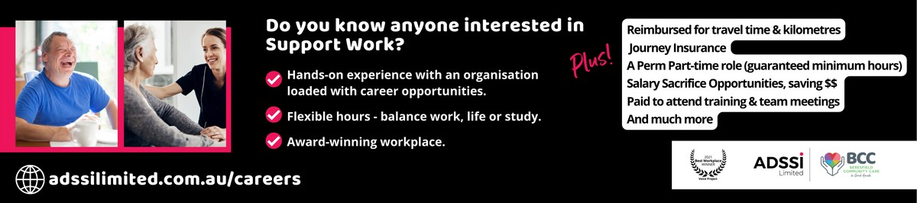
ADVISORY COUNCIL
Good news! BCC is re-establishing an Advisory Council and is calling for Expressions of Interest from interested community members.
The Council aims to engage with clients, carers, and stakeholders in a group setting (six times per year) to identify areas of improvement for BCC's service delivery, policies, and procedures.
Expressions of Interest close on Thursday, 30 June 2022. For more information or to submit an Expression of Interest, contact Alexandra Andrews, on 1300 578 478 Ext 021 or via email at alexandra.andrews@adssilimited.com.au.

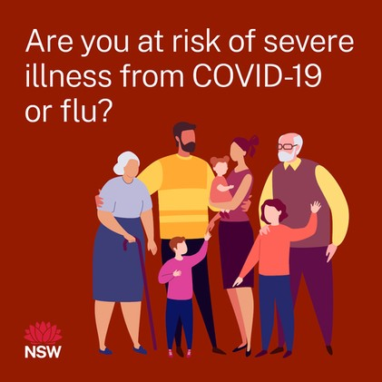Social Support - Individual and Groups
If you need help engaging with your community and family or attending BCC events, please get in touch with Deborah on
4964 1131.

Deborah can discuss available options as part of your funding.

Winter COVID-19 Booster Recommendation
People aged 16 to 64 with a medical condition that increases their risk of severe COVID-19 illness and people with disability with significant or complex health needs are recommended to receive a COVID-19 winter booster vaccination dose from 30 May 2022.

Speak to your GP or pharmacy about getting your Booster and your flu vaccine.
Energy Saving Tips for Winter

Here are some easy ways to keep warm without the bill shock.

Find a better deal.
You could potentially save hundreds of dollars by switching electricity plans to one that's ideal for your circumstances.
Visit energymadeeasy.gov.au

Make use of off-peak times.
If you're on a flexible-pricing plan (different electricity rates for other times of the day), use appliances in off-peak times when rates are lower.

Block draughts in your home.
Seal up gaps, draughty doors or floors where the air is escaping. Door snakes are a great solution.

Adjust your thermostat.
Consider wearing jumpers more and turn the heater down. It is suggested that you set your thermostat at between 18C and 20C in winter.

Switch off at the Power Point.
By switching off some of your appliances at the power point when they're not in use, you could save up to 10 per cent of your electricity bill.
For more information, visit abc.net.au/news or scan the QR code.

Disability

Ethical Provider Behaviour
The National Disability Insurance Scheme (NDIS) provides supports to people with disability to manage their own life.

Participants of the NDIS have the right to choose their providers and have preferences about whom they want to work with to receive their services.

Making decisions about which provider to choose can be challenging – there are many different providers!

It takes time to build trusting and professional relationships with Support Workers and providers.

Sometimes you might want to change service providers or ask more than one provider to deliver supports when you need them.
Illness, holidays, or training can mean that the workers you want are not always available when you want them.

Making your own choices is a really important part of the NDIS and is something BCC takes seriously.

What happens when things change?
As a participant of the NDIS, you can make choices about changing your supports or workers, and at BCC, we will try hard to make this possible.

It can be hard if your preferred or regular workers cannot change the times of supports to when it suits you.



They might be supporting other people at that time. Sometimes your favourite workers may leave and work for another provider, making it hard for you and BCC to keep things exactly as you want.

There are rules about what workers can do if your current provider, including BCC, no longer employs them. These rules help protect you from harm, abuse, exploitation or neglect. All workers have to follow a "Code of Conduct".

For example, it is not OK for a worker to contact you and try to talk you into changing providers. It is up to you to choose to switch providers, and if that's what you would like to do, we at BCC will respect your decision. We will not try to talk you into changing your mind.

It's OK to speak up if you feel unhappy if a provider or worker tries to get you to swap. You can:
Speak to them directly and ask them not to contact you anymore;
Make a complaint to the NDIS Quality and Safeguards Commission on their website (ndiscommission.gov.au) or by phone on 1800 035 544
Ask a provider, including BCC, to help you make a complaint to the Commission.
Give BCC permission to make a complaint on your behalf. You can choose how much information you want to share.

Disability

Plan Implementation Directory is now available
Please let us know:
If there are any changes to your NDIS plan.

If your plan has moved from NDIA Managed to Plan Managed.

If you have a new plan.

If the things you are funded for have changed.
The NDIS has launched the Plan Implementation Directory to support participants and their families and carers in finding the right information to make the best use of their NDIS plans.

Participants, their families and carers can use the Plan Implementation Directory to:

understand their plan start their plan
use their plan
work with providers
know what to do when something goes wrong.

The Directory has been launched as a test version, meaning they will continue to update the Directory based on feedback they get from clients.

To see the Directory on the NDIS website, visit www.ndis.gov.au/participants, or scan the QR code.

If you need help with the NDIS or anything else in this newsletter, call us on 4964 1131, and we can help you.

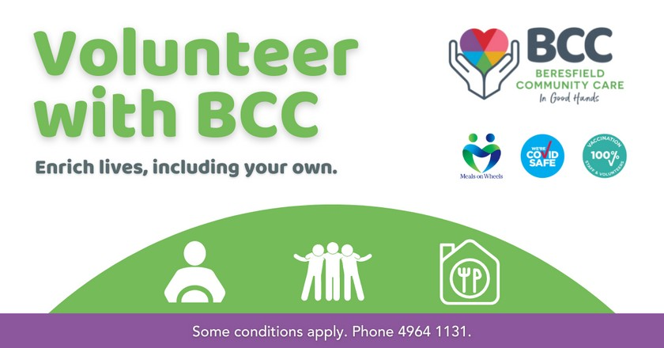W I N T E R | 2 0 2 2

We couldn't do what we do without the incredible support of our volunteers.

There are so many benefits to volunteering...

You'll join a friendly, enthusiastic team Flexibility in the days/times and roles Develop various skills and abilities Become a great role model Networking with like-minded people Free training
Personal satisfaction by giving back to your community
Increase your own social connections
Volunteer roles at BCC include: Shopping or Transport Assistant Group Activities Assistant
Social Visitor
Meals On Wheels Delivery Administration Support

BCC...
Is inclusive of diversity Provides your uniform & PPE Pays for your Flu shot Provides Journey Insurance
Reimburses for kilometres travelled AND MORE...

Phone 4964 1131 for more information.

In 2022, the NSW Government is implementing bans on plastic items.
1 June - Lightweight plastic shopping bags.
1 November - Single-use plastic straws,* stirrers and cutlery. 1 November - Single-use plastic plates and bowls.
1 November - Expanded polystyrene. 1 June 1 November
*Exemptions will apply for providing a plastic straw for people with disability or medical needs.

Roasted Vegetable Soup
This recipe is perfect for the day after a Roast Dinner! Simply cook the vegetables required along with your roast meal, and you are halfway through making this heavenly gluten- and lactose-free creation!
*if vegetables are already roasted, you can skip steps 1-4 in this recipe!

Entree, Lactose-Free, Gluten Intolerance and Coeliac Disease, Vegan, Vegetarian
Difficulty: Easy

Servings: 4
Preparation time: 30 minutes
Cooking time: 60 minutes

Ingredients
300g pumpkin, peeled and diced into 3cm cubes
250g sweet potato, peeled and diced into 3cm cubes
100g onions, peeled and diced
150g carrots, peeled and coarsely chopped 80g red capsicum, core removed, de-seeded and coarsely chopped
One garlic clove (approx 6g) unpeeled 15ml olive oil
1/2 tbsp dried mixed herbs 100ml water
500ml vegetable stock, hot Salt and pepper
Crusty bread with butter to serve

Method
Preheat the fan-forced oven to 180°C (190°C for a conventional range). Line a large roasting tray with baking paper.
Place the pumpkin, sweet potatoes, onions, carrots, capsicum and garlic on the roasting tray.
Drizzle the oil over the vegetables, sprinkle with the herbs and toss thoroughly.
Season with Salt and pepper.
Place vegetables in the oven and bake for 30 to 40 minutes until the vegetables are tender and well browned. Remove from oven and allow to cool slightly. Remove skins from the roasted garlic cloves.
Place the roasted vegetables in a large saucepan, water, and hot vegetable stock. Bring to the boil and then simmer for 10 minutes. Remove from heat and allow to cool slightly.
Using a hand mixer or food processor, carefully blend the mixture until it is a smooth consistency.
Add salt and pepper to taste.
Re-heat to boiling before serving with crusty bread and butter.

Source: Queensland Meals on Wheels https://nswmealsonwheels.org.au/our- impact/nutrition/recipes/roasted-vegetable-soup


Word Search
Can you find the words hidden in the puzzle?
Winter Clothes & Accessories

V | T | D | L | E | G | G | I | N | G | S | K
H | R | R | H | U | S | L | N | D | A | L | S
S | O | I | A | B | O | O | T | S | J | I | T
T | W | T | S | C | K | V | R | H | A | T | R
N | S | E | P | Y | K | E | A | T | C | F | A
M | E | S | A | S | E | S | O | C | K | S | I
I | D | A | N | T | A | G | U | T | E | O | N
T | S | S | T | A | E | F | S | I | T | P | C
T | E | S | S | C | A | R | F | E | T | S | O
E | A | R | M | U | F | F | S | O | N | I | A
N | T | S | D | I | R | C | O | A | T | S | T
S | W | E | A | T | S | H | I | R | T | E | T


HAT | JACKET | SWEATSHIRT
COAT | GLOVES | LEGGINGS
BOOTS | SOCKS | EARMUFFS
SCARF | SWEATER | TRACKSUIT
PANTS | MITTENS | RAINCOAT

ADSSI Limited T/A Beresfield Community Care
10/16 Huntingdale Drive, Thornton NSW 2320
E enquiries @bccare.org.au W mccs.org.au P 02 4964 1131

We are committed to reconciliation through our Reconciliation Action Plan. We affirm the right to equality, respect and fairness for LGBTIQ clients, staff and volunteers.

